**INTERNSHIP REPORT**

**On**

**E-COMMERCE WEBSITE USING UI/UX DESIGN**

*An Internship report submitted in partial fulfilment of the requirements for the*

*Award of a Degree of*

**BACHELOR OF TECHNOLOGY**

**in**

**COMPUTER SCIENCE AND ENGINEERING**

**[2021-2025]**

Submitted by

**Potnuru Venkata Sai Krishna Mourya**

**Regd. No.: 21A51A05D1**

**Under Supervision of**

**Mr.A.Pavan Kumar**

(MD)

**Infini Tech Soft LLP, Hyderabad.**

**(Duration:29th April, 2024 to 25thMay, 2024)**



**DEPARTMENT OF COMPUTERSCIENCE AND ENGINEERING**

**ADITYA INSTITUTE OF TECHNOLOGY AND MANAGEMENT**

(An Autonomous Institution)

Approved by AICTE, Permanently Affiliated to JNTUGV, Vizianagaram, Accredited by NBA (Tier – 1) and NAAC with Grade ‘A+’

K.KOTTURU, TEKKALI-532201, Srikakulam (Dist.), Andhra Pradesh, India

2024-2025

**DEPARTMENT OF COMPUTER SCIENCE AND ENGINEERING ADITYA INSTITUTE OF TECHNOLOGY AND MANAGEMENT**

(An Autonomous Institution)

TEKKALI



This is to certify that the “**Internship report”** submitted by **POTNURU VENKATA SAI KRISHNA MOURYA (Regd.No.:21A51A05D1)** is work done by him and submitted during the 2024-2025 academic year, in partial fulfilment of the requirements for the award of the degree of **BACHELOR OF TECHNOLOGY** in **COMPUTER SCIENCE AND ENGINEERING,** at **Infini Tech Soft LLP At Hyderabad.**

**Department Internship Coordinator**

**Sri. P. Anjaneyulu,** M.Tech.,

Assistant Professor, CSE

**College Internship Coordinator Dr. B. Rajesh,** Ph.D.

**Dr. Y. Ramesh,** M.Tech.,Ph.D.

**Head of the Department**

**Department of CSE**

# ACKNOWLEDGEMENT

First, I would like to thank **Mr.A.Pavan Kumar**, the Team Lead at **Infini Tech Soft LLP, Hyderabad.** for allowing me to do an internship within the organization.

I also would like all the people who worked along with me at **Infini Tech Soft LLP, Hyderabad.** with their patience and openness they created an enjoyable working environment.

I would like to thank **Sri. P. Anjaneyulu,** internship coordinator of the CSE department and **Dr. B. Rajesh,** College internship coordinator for their support and advice to get and complete an internship in above said organization.

It is indeed with a great sense of pleasure and immense sense of gratitude that I acknowledge the help of these individuals.

I would like to thank my Head of the Department **Dr. Y. Ramesh** for his constructive criticism throughout my internship.

I am highly indebted to Principal **Dr. A.S. Srinivasa Rao** and Director **Prof**. **V.V. Nageswara Rao** for the facilities provided to accomplish this internship.

I am extremely grateful to my department staff members and friends who helped me in successful completion of this internship.

**P.V.S.K.MOURYA**

**(21A51A05D1)**

# ABSTRACT

This project is undertaken at Infini Tech Soft LLP , focused on the rapid growth of E-Commerce has heightened the need for well-designed user interfaces and user experiences(UI/UX) that cater to a wide range of customers. This project focuses on creating on intuitive, responsive, and user-centered UI/UX design for an e-commerce platform that improves user engagement, ease of use, and overall satisfaction. The primary goal is to bridge the gap between technology and user needs by crafting a seamless shopping experience across various devices.

Our design process begins with thorough market research and user analysis to identify key pain points and preferences of the target audience. By employing user personas. Journey maps, and wireframes, we will create a structure that reflects the needs and behaviours of the users. Special emphasis will be placed on simplifying navigation, minimizing cognitive load, and providing users with clear, actionable information throughout their shopping journey.

To enhance the overall user experience, the platform will implement interactive features such as personalized recommendations, simplified checkout processes, and advanced filtering options. Additionally, mobile responsiveness and accessibility will be integral components of the design to ensure the platform caters to all users, regardless of their device or abilities.

Usability testing will play a critical role throughout the design process with iterative improvements based on real-time user feedback. By leveraging modern UI/UX principles, the project aims to deliver a clean, visually appealing and functional interface that drives user retention and boosts conversion rates. The final deliverable will include a fully developed UI/UX design for an e-commerce website that aligns with industry standards and best practices, ensuring a competitive edge in the online market place. By focusing on UI/UX, ecommerce business can create an engaging and user-friendly online shopping environment that drives success.

**Organization Information:**

Infini Tech Soft is an 8-year-old renowned [Corporate Branding Services Company from Hyderabad.](https://infinitechsoft.com/top-branding-services-company.html)

We are professionals in Web Design, Graphic Design, Ecommerce Websites, APP Design & Development, and Digital Marketing services. Infini Tech Soft trust in the influence to "Digital-Art".To design an effective E-Commerce website, start by understanding your customers through research and creating profiles that reflect their needs and preferences. Organize your site with a clear structure that includes main categories and subcategories, ensuring that navigation is intuitive with easily accessible menus and search features. Maintain consistency in design by using uniform colours, fonts, and styles throughout the site, and ensure it is mobile-friendly so it performs well on any device.

**Programmes and opportunities:**

Leveraging Word Press for E-Commerce with a focus on UI/UX design offers numerous programs and opportunities to enhance your skills and career. Word Press, with its versatile ecosystem, provides a range of tools and plugins specifically designed for E-Commerce, such as Word Commerce. Learning how to use these tools effectively can set you apart in the digital marketplace**.**

Participating in Word Press and e-Commerce communities, attending meet ups, and contributing to forums can provide networking opportunities and keep you updated on industry trends and best practices.

Expertise in Word Press E-Commerce UI/UX design opens various career paths, such as Word Press developer, E-Commerce consultant, or UI/UX designer. Companies often look for professionals who can create engaging, high-converting online stores. Freelance opportunities are also abundant, allowing you to work with clients to build and optimize their Word Press E-Commerce sites.

**Methodology:**

The design process will be iterative, meaning we'll create and test our designs in stages. We'll regularly gather feedback from users and make improvements based on their input. This way, we ensure that the website is not only functional but also engaging and easy to use. By continually refining our design through testing and feedback, we aim to deliver a final product that truly meets user needs and provides a great shopping experience.

**Key parts of the report:**

In our project, we prioritized clean and modular code, responsive design, and an optimal user experience to ensure a seamless and engaging online shopping environment. We integrated several advanced features to enhance user interaction and satisfaction. The **virtual fitting room** uses augmented reality (AR) technology to allow users to "try on" clothes virtually, helping them visualize how items will look before making a purchase. Additionally, we implemented **customized product recommendations** based on users' browsing history and purchase patterns, offering a more tailored shopping experience. To streamline the shopping process, we also included **enhanced product filtering** options, allowing users to search by size, style, and colour with ease.

**Benefits to the company / institution through your report:**

The Employee Management System boosts organizational efficiency by simplifying how employee information is handled and increasing administrative accuracy. It offers a single platform where all employee profiles, attendance records, and performance evaluations are managed, making it easier for HR teams to track and assess these key areas.

# Learning Objectives/Internship Objectives

* This internship offers a unique opportunity to gain practical experience in software development and enhance your skills in modern technologies. By working on real-world projects, you'll have the chance to apply your theoretical knowledge and learn from experienced professionals.
* This hands-on experience will not only strengthen your technical abilities but also provide valuable insights into industry best practices. Additionally, the internship will help you build a strong resume and improve your job prospects by showcasing your practical skills and project management experience.
* The objective of this internship is to leverage existing skills in software development while gaining deeper insights into the development and deployment of web applications. A strong internship experience can improve your chances of getting hired and advancing in your career.
* It focuses on enhancing technical proficiency and understanding of industry practices. Internships serve diverse career fields, including technology, finance, marketing, and more. They can be oriented towards hands-on project experience, research, or a combination of both.
* This internship will deepen your understanding of modern technologies like React, Django, and PostgreSQL. The experience you gain will make your resume stand out, showcasing your practical skills and project management abilities.

**INDEX**

|  |  |  |
| --- | --- | --- |
| **SLNO** | **CONTENT** | **PAGE NO** |
| 1. | Introduction  • Modules |  |
| 2. | Analysis   * Requirement Analysis * Feasibility Study |  |
| 3. | Software requirements specifications   * System Configuration * Hardware Configuration * Software Requirements |  |
| 4. | Technology   * Word Press * Woo Commerce * Wire Framing * Plugins And Themes |  |
| 5. | Source Code |  |
| 6. | Screenshots |  |
| 7. | Conclusion |  |
| 8. | Bibliography |  |
| 9. | Certificate |  |

|  |  |
| --- | --- |
| **Figure No.** | **Description** |
| Figure 1 | Home page |
| Figure 2 | Home page |
| Figure 3 | Shop page |
| Figure 4 | About page |
| Figure 5 | Contact |



# WEEKLY OVERVIEW OF INTERNSHIP ACTIVITIES:

# 

|  |  |  |  |
| --- | --- | --- | --- |
| **1st WEEK**  W | **DATE** | **DAY** | **NAME OF THE TOPIC/MODULE**  **COMPLETED** |
| 29/04/2024 | Monday | Introduction Of UI/UX Designing. |
| 30/04/2024 | Tuesday | Basic Fundamentals Of UI/UX. |
| 01/05/2024 | Wednesday | Understanding User Research And Personas. |
| 02/05/2024 | Thursday | Wire Framing And Information Architecture. |
| 03/05/2024 | Friday | Prototyping Tools And Techniques. |
| 04/05/2024 | Saturday | UI/UX Design Workshop. |

|  |  |  |  |
| --- | --- | --- | --- |
| **2nd WEEK** | **DATE** | **DAY** | **NAME OF THE TOPIC/MODULE**  **COMPLETED** |
| 06/05/2024 | Monday | Visual Design Principles For UI/UX. |
| 07/05/2024 | Tuesday | Interaction Design And User Flows. |
| 08/05/2024 | Wednesday | Mobile App Design Best Practices. |
| 09/05/2024 | Thursday | Web Design Layouts And Responsive Design. |
| 10/05/2024 | Friday | Design Thinking And Ideation. |
| 11/05/2024 | Saturday | UI/UX Portfolio Building. |

|  |  |  |  |
| --- | --- | --- | --- |
| **3rd WEEK** | **DATE** | **DAY** | **NAME OF THE TOPIC/MODULE**  **COMPLETED** |
| 14/05/2024 | Tuesday | Accessibility And Inclusive Design. |
| 15/05/2024 | Wednesday | Usability Testing And Feedback. |
| 16/05/2024 | Thursday | Front-end Development Basics For Designers. |
| 17/05/2024 | Friday | Portfolio Building And Presentation Skills. |
| 18/05/2024 | Saturday | UX Writing And Micro copy. |

|  |  |  |  |
| --- | --- | --- | --- |
| **4th WEEK** | **DATE** | **DAY** | **NAME OF THE TOPIC/MODULE COMPLETED** |
| 20/05/2024 | Monday | Advanced Prototyping And Animation Workshop. |
| 21/05/2024 | Tuesday | Career Paths In UI/UX Design. |
| 22/05/2024 | Wednesday | Industry Trends And Emerging Technologies. |
| 23/05/2024 | Thursday | Team Dividing And Project Assigning And Working On It. |
| 24/05/2024 | Friday | Final Project Work And Review. |
| 25/05/2024 | Saturday | Final Project Work & Review And Certificate. |

## INTRODUCTION

The purpose of the project was to design and develop a travel blog website according to the actual situation and the characteristics of blog interactivity, aiming at providing a platform for website visitors to communicate with each other and for sharing travel information between visitors. On the basis of the characteristics of the blog sharing, the travel blog website can promote information and knowledge exchange among users. In Finland, websites are widely used. Basically, governments, schools, enterprises and even supermarkets all have their own websites. People can find desired information on these websites conveniently. In addition, there are a lot of people having their own blog sites, which makes the information spread more rapidly and forms a unique blog culture. Blogs cover a wide range of topics, from cooking to travelling, from fashion to photography. In 1994, the first blog was created. The progress of blog until the current microblogging platform is extremely important on the Internet development. Nowadays, there are many different ways to build a blog on the Internet, such as Word Press, Tumble, Square space. Even so, Word Press hosted 74.6 million websites approximately in February 2014. It is a popular platform for building blogs. Moreover, Word Press sites occupied18.9% of all self-hosted websites at that time. As a matter of fact, 75 million websites were operated by Word Press until the end of 2016 . Hence, in this thesis study, Word Press was chosen as the platform for the travel blog website. The objective of this travel blog includes providing a platform for learning and communicating information between website visitors, sharing photos and stories of travel around the world. A user can not only read the travel story on the travel blog, but users can also contribute their own stories to administrator on blog. This kind of behavior promotes the spread of information. Even if users do not go out, they can still view different landscapes and experience different cultures through the travel blog. The user requires only a mobile device or a desktop computer.

## 

**ANALYSIS:**

**Requirement Analysis:**

Before coding in a project, the requirements specification of the website needs to be prepared. It is used for describing the user interactions that the website must provide. It includes functional requirements and non functional requirements. The requirements specification of this blog website was implemented individually instead of cooperating with a client.

**User Interface (UI):**

* Clear navigation for managing employee profiles, attendance, and performance.
* Intuitive dashboard with accessible options for administrators and employees.
* Visually appealing and responsive design for seamless interaction across devices.

**Functionality:**

* Real-time addition, editing, and management of employee records.
* Ability to track attendance, manage profiles, and evaluate performance.
* Automated calculations for attendance and performance metrics.
* Secure role-based access control for different user roles (admin, HR, employees).
* Integration with existing HR systems and tools for smooth data handling.

**Performance:**

* Fast loading times for employee data updates.
* Minimal latency in processing attendance and performance evaluations.
* Redundancy and backup systems to ensure data reliability and availability.

**Security:**

* Secure transmission and storage of sensitive employee data.
* Protection against common vulnerabilities such as unauthorized access, SQL injection, and data.

**Compatibility:**

* Cross-browser and cross-device compatibility for both desktop and mobile access.
* Integration with external APIs and third-party tools for data synchronization and reporting.

**Scalability:**

* Ability to scale the system to handle growing employee databases as the organization expands.
* Support for additional modules or features as needed (e.g., payroll, benefits management).

**Testing:**

* Rigorous testing for usability, performance, and security.
  + User acceptance testing to ensure the system meets organizational needs.
* **Documentation:**
  + Comprehensive documentation for system administrators, developers, and HR personnel.
  + User guides for employees and managers to navigate and use the system effectively.
* **User Feedback and Analytics:**
  + Integration with analytics tools to monitor system usage and performance.
  + Mechanisms for collecting user feedback to continuously improve the platform.
* **Maintenance and Support:**
  + Ongoing maintenance to resolve bugs and introduce system updates.
  + Responsive support to assist users with technical issues related to the platform.

### Feasibility Study:

### A preliminary investigation was conducted to examine to feasibility study is crucial to assess the potential success of the **Personalized Fashion Retail Platform** project before proceeding with its development. It examines the project from several angles: technical, economic, operational, and legal feasibility. All systems are feasible with unlimited resources and time, but this study focuses on the following aspects:

* Technical Feasibility
* Economic Feasibility
* Operational Feasibility
* Legal And Regulatory Feasibility
* Market Feasibility

### ****1.Technical Feasibility:****

### This aspect evaluates whether the technology required to implement the project is available and capable of delivering the desired functionality.

**2. Economic Feasibility:**

This analysis evaluates whether the project is financially viable, considering costs, potential revenues, and return on investment (ROI).

**3. Operational Feasibility:**

This part examines whether the project can be successfully implemented and managed within the existing organizational structure and processes.

**4. Legal and Regulatory Feasibility:**

Compliance with legal and regulatory standards is critical for the successful launch and operation of the platform.

**5. Market Feasibility:**

There is a clear demand for personalized fashion platforms, and the market potential is high, particularly with a focus on engaging user experiences and technology-driven personalization.

**Functional Requirements Design:**

The functional requirements assign what the website should do. In the thesis’s blog website, the designed functional requirements are: — With the website, users should be able to follow and browse the latest images, stories and blogs. — With the website, users should be able to contact the blogger and upload the images and stories that they wish to share. — With the website, users should be able to comment the blog. — The administrator should be able to manage images, stories and blogs in the admin system. — The administrator should be able to get the message from the user and choose the interesting images and stories to post on the blog.

**Non-Functional Requirements Design:**

The non-functional requirements describe how a website operates. There are some representative non-

functional requirements: capacity, reliability, maintainability, performance, modifiability. In the thesis’s blog website, the designed non functional requirements are: — The admin system should provide content modifiability. — The website should be responsive, dynamic and user-friendly.

**Technical Requirements:**

Technical requirements are the backbone of your Word Press site, covering the software and hardware necessary to keep it running smoothly. Your hosting provider must support Word Press’s needs, including PHP 8.0+ and MySQL 5.7+ to ensure compatibility. Options range from shared hosting for small sites to VPS or dedicated servers for high-traffic websites. Managed Word Press hosting services, such as WP Engine or Kinsta, simplify maintenance with automatic updates and backups. Additionally, secure your domain name early on and ensure your hosting provider offers SSL certificates to protect user data and improve SEO rankings. These technical foundations are critical for a fast, reliable, and secure website. Design Requirements.

**Design Requirements:**

The user interface (UI) must be intuitive and aesthetically pleasing, with a consistent color scheme, and

layout. User experience (UX) plays a significant role in ensuring easy navigation, fast loading times,

and accessibility for all users, including those with disabilities.

**UI/UX design** focuses on creating intuitive, user-friendly interfaces that meet the needs and expectations of users. Effective design requires a careful consideration of various factors. Here are some key design requirements:

* **Clarity and Simplicity:** Interfaces should be easy to understand and use, avoiding unnecessary complexity.
* **Intuitive Navigation:** Users should be able to navigate through the interface effortlessly.
* **Consistent Design:** Maintain a consistent visual language and interaction patterns throughout the product.
* **Accessibility:** Ensure the design is accessible to users with disabilities, adhering to accessibility guidelines.
* **User-Centered Design:** Prioritize the needs and preferences of users throughout the design process.

**SOFTWARE REQUIREMENTS SPECIFICATIONS**

**System Configurations:**

The Software Requirements Specifications (SRS) document outlines the functional and non-functional requirements for the Personalized Fashion Retail Platform. This document serves as a blueprint for development, ensuring all stakeholders have a clear understanding of the system’s capabilities and constraints.

**Software Requirements:**

* Operating System: Windows or Linux
* Front End: HTML5, CSS3, UIUX
* Back End: MySQL/Postgre SQL

**Hardware Requirements:**

* Processor: Intel Core i5 or higher
* Memory: 8GB RAM
* Hard Disk: 256 GB SSD or higher

**Word Press Server Requirements:**

**Server requirements involve several elements:** RAM, database version, processing power, diskspace,

the web server used.

Here’s a quick look into the standard recommendations for a server when running Word Press:

* **Web server:** Nginx or Apache with mod-rewrite module.
* **Disk space:** At least 1 GB.
* **PHP:** Version 8.0 or higher.
* **Database:** MySQL 5.015 or higher (An alternative is Maria DB, version 10.1 or higher).
* **RAM (Random Access Memory):** At least 512 MB.
* **CPU (Central Processing Unit):** At least 1.0 GHz.
* Support for HTTPS.

**WEB TECHNOLOGIES DEVELOPMENT**

**Word Press:**

Word Press, initially a simple blogging platform, has evolved into a versatile Content Management System (CMS) that powers millions of websites worldwide. Its user-friendly interface and extensive plugin ecosystem have made it a popular choice for designers and developers alike. Let's delve into how Word Press can be leveraged to create exceptional UI/UX experiences.

### Key Advantages of Word Press for UI/UX:

* **Customization and Flexibility:**
  + **Themes:** Word Press offers a vast library of pre-designed themes that can be customized to match specific branding and design requirements.
  + **Plugins:** A plethora of plugins are available to extend Word Press' functionality, allowing for the integration of various features like contact forms, sliders, social media feeds, and more.
  + **Custom Code:** For advanced customization, developers can write custom code to tailor the appearance and behavior of the website.
* **User-Friendliness:**
  + **Intuitive Interface:** Word Press' intuitive dashboard makes it easy for non-technical users to manage content, update settings, and make basic design changes.
  + **WYSIWYG Editor:** The visual editor allows users to create and edit content without needing to write HTML code.
* **SEO Optimization:**
  + **Built-in SEO Features:** Word Press comes with built-in SEO features that help improve search engine rankings, such as meta titles, meta descriptions, and permalinks.
  + **SEO Plugins:** Additional SEO plugins can be used to optimize websites further, including keyword research, sitemaps, and social media integration.
* **Accessibility:**
  + **Accessible Themes and Plugins:** Many Word Press themes and plugins are designed with accessibility in mind, ensuring that websites can be used by people with disabilities.
  + **Accessibility Standards:** Word Press can be configured to adhere to accessibility standards like WCAG (Web Content Accessibility Guidelines).
* **Community and Support:**
  + **Active Community:** Word Press has a large and active community of users, developers, and designers who can provide support, share knowledge, and contribute to the platform's growth.
  + **Extensive Documentation:** Official documentation and forums are available to help users learn and troubleshoot Word Press.

**Wire framing:**

**Wire framing** is a crucial stage in the UI/UX design process that involves creating low-fidelity representations of a digital product's interface. These representations focus on the layout, structure, and hierarchy of content, without delving into visual details like colours, typography, or imagery.

### Why Wire framing is Essential:

* **Early-Stage Feedback:** Wireframes allow for early feedback from stakeholders, ensuring that the product's core functionality and structure align with their vision.
* **Focus on Structure:** By focusing on layout and content organization, wireframes help designers prioritize key elements and avoid unnecessary clutter.
* **Iteration and Refinement:** Wireframes can be easily modified and iterated upon, allowing designers to experiment with different layouts and features before investing time and resources into visual design.
* **Foundation for Visual Design:** Wireframes provide a solid foundation for the visual design phase, ensuring that the final product has a clear and intuitive user interface.

### Key Components of a Wireframe:

* **Layout:** The arrangement of elements on the page, including headers, footers, navigation, and content areas.
* **Content:** The type and placement of content, such as text, images, buttons, and forms.
* **Hierarchy:** The visual importance of elements, with more important elements being given prominence.
* **Interactions:** Basic interactions like clicking, hovering, and scrolling.

### Wire framing Tools and Techniques:

* **Pencil and Paper:** A traditional method that allows for quick sketching and experimentation.
* **Digital Tools:** Software like Figma, Adobe XD, Sketch, and Balsamiq offer features for creating wireframes efficiently.
* **Low-Fidelity Prototyping:** Creating interactive wireframes to simulate user interactions and gather feedback.

### Best Practices for Wire framing:

* **Keep it Simple:** Focus on the core functionality and avoid unnecessary details.
* **Use Consistent Symbols:** Create a library of symbols for commonly used elements to maintain consistency.
* **Annotate Wireframes:** Add notes to explain specific design decisions or interactions.
* **Involve Stakeholders:** Share wireframes with stakeholders early in the process to gather feedback and ensure alignment.
* **Iterate and Refine:** Continuously improve your wireframes based on feedback and testing.

By following these guidelines, you can create effective wireframes that serve as a solid foundation for your digital product's UI/UX design.

**Woo Commerce:**

**Woo Commerce** is a popular e-commerce plugin for Word Press, offering a flexible and customizable platform for online stores. It plays a significant role in UI/UX design, allowing businesses to create visually appealing and user-friendly online shopping experiences.

### Key UI/UX Benefits of Woo Commerce:

* **Customization:**
  + **Themes:** Woo Commerce offers a vast selection of themes designed specifically for e-commerce, providing various layouts and styles to suit different brands and products.
  + **Plugins:** A wide range of plugins can be used to customize the appearance and functionality of your online store, including product sliders, mega menus, and advanced search options.
* **User-Friendly Interface:**
  + **Intuitive Checkout:** Woo Commerce provides a streamlined checkout process, minimizing friction and encouraging conversions.
  + **Product Pages:** Product pages can be designed to highlight key features, images, and customer reviews, enhancing the shopping experience.
  + **Shopping Cart:** The shopping cart functionality is user-friendly, allowing customers to easily add, remove, and view their items.
* **Mobile Optimization:**
  + **Responsive Design:** Woo Commerce themes are typically responsive, ensuring that your online store looks great and functions well on various devices, including smartphones and tablets.
* **Search Engine Optimization (SEO):**
  + **SEO-Friendly Structure:** Woo Commerce is designed with SEO in mind, making it easier for search engines to index and rank your products.
  + **SEO Plugins:** Additional SEO plugins can be used to optimize your product pages, meta descriptions, and site structure.
* **Payment and Shipping Integrations:**
  + **Multiple Payment Options:** Woo Commerce supports a variety of payment gateways, including popular options like PayPal, Stripe, and Authorize.Net.
  + **Shipping Options:** You can configure various shipping methods and rates to accommodate different locations and delivery preferences.

### Tips for Enhancing UI/UX with Woo Commerce:

* **Choose a Responsive Theme:** Ensure that your online store is accessible and easy to navigate on all devices.
* **Optimize Product Pages:** Use high-quality images, clear descriptions, and customer reviews to make your products appealing.
* **Simplify the Checkout Process:** Minimize the number of required fields and offer guest checkout options to reduce friction.
* **Provide Excellent Customer Support:** Offer timely and helpful customer support to address any questions or issues.
* **Test and Iterate:** Continuously test your online store and make improvements based on user feedback and analytics.

By effectively utilizing Woo Commerce's features and following UI/UX best practices, you can create a compelling and engaging online shopping experience for your customers.

## Plugins and Themes in UI/UX:

**Plugins** and **themes** are essential components of the Word Press ecosystem, offering a vast array of options for customizing the appearance and functionality of your website. These elements play a crucial role in UI/UX design, allowing you to create unique and engaging experiences for your users.

### Themes:

* **Visual Foundation:** Themes provide the overall look and feel of your website, including layout, color scheme, typography, and widgets.
* **Customization Options:** Many themes offer options to customize elements like headers, footers, and sidebars.
* **Responsive Design:** Ensure your website looks great on all devices by choosing a responsive theme.
* **Popular Themes:** Popular themes include Astra, Ocean WP, Divi, and Generate Press.

### Plugins:

* **Functionality Extensions:** Plugins add new features to your Word Press website, such as contact forms, sliders, social media integration, and e-commerce capabilities.
* **Customization Options:** Plugins often provide settings to tailor their behavior to your specific needs.
* **Popular Plugins:** Popular plugins include Yoast SEO, Elementor, Woo Commerce, and Jetpack.

### UI/UX Considerations for Plugins and Themes:

* **Compatibility:** Ensure that your chosen plugins and themes are compatible with your Word Press version and other installed plugins.
* **Accessibility:** Choose plugins and themes that prioritize accessibility to ensure your website is usable by people with disabilities.
* **User Experience:** Consider how plugins and themes will impact the overall user experience. For example, a cluttered layout or slow loading times can negatively affect user satisfaction.
* **Mobile-First Design:** Prioritize themes and plugins that are designed for mobile devices, as an increasing number of users access websites on smartphones and tablets.

### Best Practices for Using Plugins and Themes:

* **Regular Updates:** Keep your plugins and themes up-to-date to ensure compatibility and security.
* **Limit Plugin Usage:** Avoid using too many plugins, as this can slow down your website's performance.
* **Test Changes:** Before making significant changes to your website, test them on a staging site to avoid unexpected issues.
* **Consider Alternatives:** If a plugin or theme is causing problems, explore alternative options.
* **Backup Your Website:** Always create a backup of your website before making major changes.

By carefully selecting and using plugins and themes, you can create a visually appealing and user- friendly Word Press website that meets your specific needs and goals.

**Domain Names and Hosting**

**Domain Names:**

A domain name refers to the URL people type in a web browser’s address bar to access your site. In other words, domain names offer a convenient way for people to access websites.

Without it, they would have to use a numerical label assigned to every website and server on the internet, also known as an [IP address](https://www.hostinger.in/tutorials/what-is-ip-address).

Generally, domain names are comprised of two main parts a second-level domain (SLD) and [a top-level domain (TLD)](https://www.hostinger.in/tutorials/what-is-tld). Second-level domains usually consist of words or phrases, while top-level domains are the predetermined extensions that follow.

For example, in the case of google.com, the second-level domain is google, and .com is the TLD.

To get a domain name for your website, you need to register it first. Domain registration is the process of reserving a name on the internet for a certain period. Usually, you need to [renew the license](https://www.hostinger.in/tutorials/how-to-renew-domain-name) once per year, but you can pay up in advance for up to 10 years for the domain to be registered under your name.

* Generic Top-Level Domains (GTLD’s) The most commonly used domains are gTLDs. Domain name extensions like [.com](https://hostadvice.com/blog/domains/what-does-the-com-domain-represents/), .net, [.org](https://hostadvice.com/blog/domains/in-a-url-what-does-org-represent/) are commonly used by websites with a global audience, while .com is the most popular one.
* Country-Code Top-level Domains (CCTLD’s) : Two-letter domains that represent specific countries or geographic locations. Examples include .uk for the United Kingdom or .jp for Japan.
* Sponsored Top-Level Domains (STLD’s) : Domains that are sponsored by specific organizations or agencies. For example, .gov for U.S. governmental entities and .edu for educational institutions.

**Hosting :**

[Web hosting is](https://www.hostinger.in/tutorials/what-is-web-hosting/) a service that allows you to publish the website on the internet. If you buy a hosting service from a provider, you will have a portion of their web servers to store your website’s files and data.

In addition to storing website files, a web host protects the server and your website files from malicious attacks.

**Types of Hosting:**

* **Shared Hosting:** This is the most common and affordable type, where multiple websites share a single server.
* **Virtual Private Server (VPS) Hosting:** A VPS provides dedicated server resources, offering more control and performance than shared hosting.
* **Dedicated Server Hosting:** This provides a complete server for your exclusive use, offering maximum control and performance.
* **Cloud Hosting:** This utilizes a network of servers to distribute workload and ensure high availability.
* Factors to Consider When Choosing Hosting:
* **Website Size and Traffic**: The amount of content and expected traffic will determine the required hosting resources.
* Scalability: Consider whether your website needs to be easily scaled up or down to accommodate growth.
* **Features:** Look for features like email hosting, SSL certificates, and website builders.
* **Reliability and Support:** Choose a hosting provider with a good reputation for uptime and customer support.

**TECHNOLOGY**

The aim of this chapter is to give a description of what kinds of software, technology, tools and programming languages were used in this project.

**Word Press:**

Word Press is a user-friendly content management system(CMS) that can be used to create websites, applications and blogs. It is a free open source software based on MySQL and PHP. It should be installed at a web hosting or a software platform which can support PHP, MySQL and HTTPS. For instance, MAMP for Mac operating system, XAMPP for Windows operating system, and LAMP for Linux operating system. Nowadays many websites are developed by Word Press because of the multiple themes and user friendly management system. Developers can create a customized theme and use various plugins according to customers’ requirement. Website administrators can use the Word Press CMS to add and delete contents of website easily. There are some successful and popular cases, such as Angry Birds, BBC America, Vogue India and Mercedes-Benz. With these advantages, Word Press is daily used by millions of websites and seen by tens of millions of users because it is the largest and the most popular tool for self-hosted blogging service all over the world. Thus, Word Press is supporting and powering 26.4% of the Web on the basis of stats since March 2016, and it keeps increasing .

**Web Hosting:**

The web hosting service uses the data center’s computer clusters and storage devices to provide free or paid service for a client. It allows individuals and organizations to publish a website to the Internet. Normally, the hosting company will provide a control panel for the client to upload the web content remotely. Then others can access the website by entering the website address or domain name into the browser. There are several advantages of web hosting. Firstly, compared with the purchase of independent servers, the cost of website construction has been greatly reduced, which has greatly facilitated the popularity of small and medium- sized websites. Secondly, using the technology of web hosting, a real host can be divided into a number of virtual hosting. Each web hosting has an independent domain name and IP address ,and it has full Internet server functionality as well. In addition, the high-efficiency is a significant benefit. The efficiency of website building has improved when using the web hosting, but it takes a longer time if a user purchases the server and installs the operating system and software application by themselves. On the other hand, the web hosting has also some disadvantages. First, some functions are limited by the server providers, such as forum programs and traffic statistics functions. Then, the website design needs to consider the functional support provided by the service provider, such as the database type or operating system. Furthermore, some websites using the web hosting are slow 11 to access.

**UI Design:**

The design part is the beginning phase of a project or product, and it is very important for the product usability. Usability is a user-centered design concept. The design of usability focuses on how to make the product design meet a user’s habit and need. The design of an Internet site, for example, aims that users can have a smooth browsing process. The judge criterion of the usability can be divided into three aspects: effectiveness, efficiency and satisfaction. There are three primary results of the usable interface.

UI Design focuses on organized structure and prioritization, visual equilibrium, visual distinction, focal points and highlights, guiding the user’s attention, consistent design elements, visual cohesion.

**UX Design:**

UX focuses on the overall experience a user has with a product or service. It is more about the structure, usability, and overall journey rather than visual design. Key aspects include:

* **User research:** Understanding user behaviours, needs, and pain points through interviews, surveys, or analytics.
* **Wire framing & prototyping:** Designing the flow and structure of a product before the visual details are added.
* **Usability:** Ensuring that the product is easy to use and efficient in helping users achieve their goals.
* **Information architecture:** Organizing content in a logical and accessible way.
* **Wire framing:** Creating low-fidelity representations of the interface to visualize layout and structure.
* **Prototyping:** Building interactive prototypes to test user interactions and gather feedback.
* **Visual Design:** Designing the visual elements of the interface, including colours, typography, and imagery.
* **Usability Testing:** Evaluating the usability of the interface through testing with real users.
* **Iterative Design:** Continuously improving the design based on feedback and testing.

**Best Practices for UX Design:**

* **Empathy:** Understand your users' needs and perspectives.
* **Simplicity:** Keep the interface clean and uncluttered.
* **Consistency:** Maintain consistency in design elements, typography, and terminology.
* **Clarity:** Use clear and concise language to convey information effectively.
* **Efficiency:** Minimize user effort by streamlining tasks and reducing unnecessary steps.
* **Accessibility:** Ensure that your interface is accessible to users with disabilities.
* **Feedback:** Provide clear and timely feedback to users, guiding them through the interface.

**Tools and Techniques:**

* **Design Software:** Figma, Adobe XD, Sketch, InVision, and Balsamiq are popular tools for creating wireframes, prototypes, and visual designs.
* **User Research Methods:** Surveys, interviews, focus groups, and usability testing are common methods for gathering user insights.
* **A/B Testing:** Experimenting with different design variations to determine which performs better.

**IMPORTANCE OF UI/UX DESIGN:**

### Web Design:

### Web Design is a crucial aspect of UI/UX, focusing on creating visually appealing and user-friendly digital products.

**Business Success:** In a competitive digital landscape, UI/UX design can be a significant differentiator. Well-designed websites and applications can attract and retain customers, boost conversion rates, and ultimately drive business success.

* **User Retention:** User-friendly designs keep visitors engaged and coming back for more. A seamless and enjoyable user experience encourages customer loyalty and word-of-mouth recommendations.
* **Reduced Support Costs:** A well-thought-out UX can minimize user confusion and the need for customer support, saving businesses time and money.
* **Accessibility and Inclusivity:** UI/UX design should prioritize accessibility to ensure that all users, regardless of abilities or disabilities, can use and navigate digital products. Inclusivity is not just a moral imperative but often a legal requirement.
* **Brand Identity:** Consistent and visually appealing UI design elements contribute to the establishment of a strong and memorable b rand identity.
* **Practices in UI Design:**
* **Visual Hierarchy:** Create a clear visual hierarchy to guide users' attention to the most important elements on the page. Use design elements like size, colour, and positioning to achieve this.
* **Consistency:** Maintain consistency in design elements throughout the website or application. This includes using a consistent colour scheme, typography, and button styles.
* **User Feedback:** Provide visual feedback to users when they interact with UI elements. For example, buttons should change appearance when clicked to confirm the action.
* **Practices in UX Design:**
* **User Research:** Conduct user research to understand your target audience's needs, behaviours, and pain points. This insight should inform design decisions.
* **Information Architecture:** Organize the content and features logically. A clear information architecture makes it easier for users to find what they need.
* **Usability Testing:** Regularly test your website or application with real users to identify issues and gather feedback for improvement.
* **User Flows:** Map out user flows to understand how users navigate through the site or app. Optimize these flows for efficiency and satisfaction.

**User-Centered Design:**

* **Empathize with Users:** Understand your target audience's goals, pain points, and behaviours.
* **Conduct User Research:** Gather insights through interviews, surveys, usability testing, and analytics.
* **Involve Users in the Process:** Seek feedback throughout the design and development stages.

**Simplicity and Clarity:**

* **Minimalist Design:** Avoid clutter and focus on essential elements.
* **Clear and Concise Language:** Use simple, easy-to-understand language.
* **Intuitive Navigation:** Make it easy for users to find what they need.
* **Consistency:**
  + **Consistent Design Patterns:** Maintain a consistent visual language and interaction patterns.
  + **Brand Guidelines:** Adhere to your brand's guidelines for colors, typography, and imagery.
* **Accessibility:**
  + **Inclusive Design:** Ensure your designs are accessible to users with disabilities.
  + **Adhere to Standards:** Follow accessibility guidelines like WCAG (Web Content Accessibility Guidelines).
* **Feedback and Iteration:**
  + **Gather Feedback:** Continuously seek feedback from users and stakeholders.
  + **Iterate and Improve:** Use feedback to make improvements and refine your designs.

### Mobile-First Approach:

* **Prioritize Mobile:** Design for mobile devices first to ensure a great experience on smaller screens.
* **Responsive Design:** Ensure your designs adapt to different screen sizes and orientations.

### Performance Optimization:

* **Minimize Load Times:** Optimize images, code, and server performance.
* **Provide Progress Indicators:** Keep users informed of loading progress.

### Testing and Validation:

* **Usability Testing:** Conduct tests to identify usability issues and areas for improvement.
* **A/B Testing:** Experiment with different design variations to determine what works best.

### Stay Updated:

* **Follow Design Trends:** Stay informed about emerging design trends and best practices.
* **Continuously Learn:** Invest in your design skills and knowledge.

By following these best practices, you can create UI/UX designs that are not only visually appealing but also functional, user-friendly, and effective in achieving your design goals.

Effective UI/UX design requires a focus on user-centered principles, simplicity, consistency, accessibility, and continuous improvement. By understanding user needs, creating intuitive interfaces, maintaining a consistent visual language, ensuring accessibility, and gathering feedback for iteration, designers can create products that are not only visually appealing but also functional, user-friendly, and effective in meeting their goals.

Effective UI/UX design is a delicate balance of art and science, requiring a deep understanding of user needs, technical proficiency, and a keen eye for aesthetics. By adhering to a set of best practices, designers can create interfaces that are not only visually appealing but also intuitive, functional, and accessible to a wide range of users.

At the core of successful UI/UX design lies a user-centered approach. Designers must empathize with their target audience, understanding their goals, pain points, and behaviors. This involves conducting thorough user research, such as interviews, surveys, usability testing, and analytics, to gather valuable insights. By involving users throughout the design process, designers can ensure that their creations meet real-world needs and expectations.

Simplicity and clarity are paramount in UI/UX design. Cluttered interfaces can be overwhelming and confusing for users, hindering their ability to complete tasks efficiently. By focusing on essential elements and using clear, concise language, designers can create interfaces that are easy to navigate and understand. A minimalist approach can also contribute to a more visually appealing and uncluttered design.

Consistency is another key factor in effective UI/UX design. Maintaining a consistent visual language and interaction patterns throughout the product helps users feel familiar and comfortable. This includes adhering to brand guidelines for colors, typography, and imagery, as well as using consistent design patterns for elements like buttons, menus, and forms.

Accessibility is a critical aspect of inclusive design. Ensuring that your interfaces are accessible to users with disabilities is not only a moral obligation but also a legal requirement in many jurisdictions. By following accessibility guidelines like WCAG (Web Content Accessibility Guidelines), designers can create interfaces that are usable by a wider range of people.

Continuous improvement is essential in UI/UX design. Gathering feedback from users and stakeholders throughout the design and development process allows designers to identify areas for improvement and iterate on their designs. A/B testing can also be used to experiment with different design variations and determine what works best.

In addition to these core principles, designers should also consider factors like mobile-first design, performance optimization, and staying updated with emerging trends and best practices. By following these guidelines, designers can create UI/UX experiences that are not only visually appealing but also functional, user-friendly, and effective in achieving their design goals.

## IMPLEMENTATION

In this chapter, the implementation phase of the website will be introduced.

**Setting up a Server:**

The implementation phase was started by choosing the web hosting and domain name. Host Gator was chosen as the web hosting service provider in the beginning. It also includes the service that registers the domain name. Host Gator, as one of the top ten host companies in the United States, currently hosts more than 9 million domains and has over 400,000 customers. It is very friendly for a personal user due to the decent price. A Hatchling plan was picked from hosting plan options, because it included a domain. yuping.co was chosen for the domain name used for the thesis project. With regard to .co, it is the Internet country code top-level of a domain assigned to Columbia. Meanwhile, in Japan, South Korea and some Common wealth countries, the company domain name .com is replaced by .co frequently.After the web hosting and domain name is paid, the Host Gator system will provide an account about the Control Panel to the user. In the Control Panel which plays a role as a server management side, the user can manage files and install plugins.

**Installing Word Press:**

The user can install the Word Press on the Control Panel easily because of the Marketplace of Control Panel includes Word Press. Figure 1 shows the user interface when the user is installing the Word Press on the Control Panel. Then in this thesis, “yuping.co” was chosen as the domain, and “wp” was chosen as the directory in the form. start by downloading the latest version of Word Press from WordPress.org. After downloading, upload the Word Press files to your web server, typically in the "public html" or a similar directory. Once the files are in place, create a MySQL database and a database user from your hosting control panel (like c Panel). Then, navigate to your domain in a web browser, which will launch the Word Press setup wizard. During the setup, provide your database details (database name, username, and password), then set the site title, admin username, password, and email. After completing the setup, you can log in to your Word Press dashboard and start customizing your site by choosing themes, installing plugins, and adding content. If you are installing Word Press locally for development purposes, tools like XAMPP or MAMP can be used to set up a local environment, following similar steps but on your own machine.

**Here is a step-by-step guide to install Word Press manually:**

* **Download Word Press:** 
  + Go to WordPress.org.
* Click the Download Word Press button to get the latest version of Word Press.
* The file will be a .zip archive.

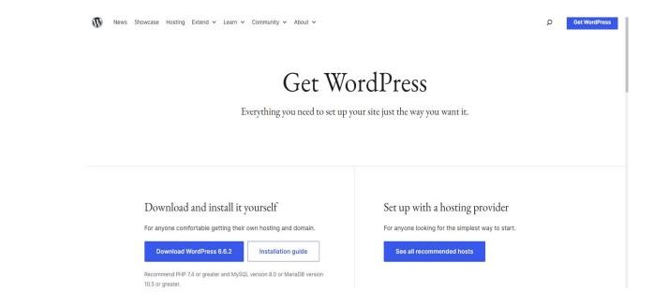

* **Upload Word Press to Your Web Server:**
* Extract the Word Press .zip file on your computer.
* Navigate to the root directory of your website(public_ html or www).
* **Create a MySQL Database:**
* Log in to your hosting provider’s c Panel (or other control panel).
* Under the Databases section, select MySQL Databases.
* Assign the user to the new database and make sure to grant.

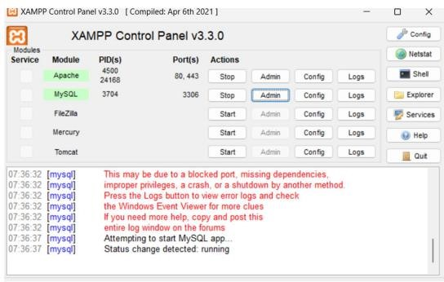

* **Configure the Word Press Files:**
* In the Word Press files you uploaded, locate the file named wp-config-sample.php.
* Rename it to wp-config.php.

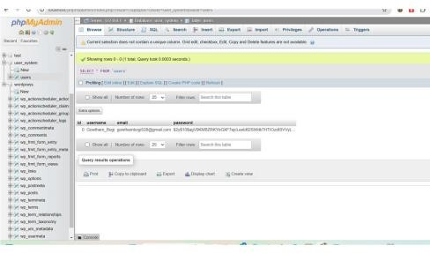

* **Replace the following lines with your database details:**
* **Php Code:**
* define( 'DB_NAME', 'your_database_name' );
* define( 'DB_USER', 'your_database_user' );
* define( 'DB_PASSWORD', 'your_database_password' );
* define( 'DB_HOST', 'localhost' ); • Save the changes.
* **Run the Word Press Installation Script:s** 
  + - In your web browser, go to your domain.
    - This will start the Word Press installation wizard.
    - Select your language and click Continue.
* **Configure Your Website:** 
  + **Site Title:** The name of your website.
  + **Username:** The admin username (used for logging into Word Press).
* **Password:** A strong password for the admin user.
* **Your Email:** The email address associated with the admin user.
* Click Install Word Press.
* **Log In to Word Press:**
* Once the installation is complete, click Log In.
* Enter your admin username and password to access the Word Press.

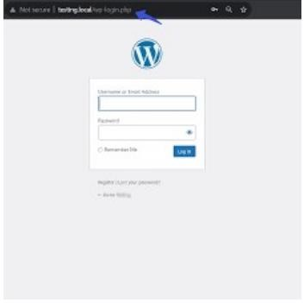

After you log in to your Word Press dashboard for the first time, there are several important steps you can take to set up and customize your website. Here's a guide on what to do next:

* **Set Up General Site Information:** 
  + **Site Title:** If you didn’t set it during installation, add or update the title of your site here.
  + **Tagline:** A short phrase or slogan describing your site (optional).
  + **Time Zone:** Set the correct time zone for your location.
  + **Date and Time Format:** Customize how dates and times appear on your site.

* **Step-by-Step Guide to Installing and Activating Plugins in Word Press:** 
  + - Access the Word Press Dashboard.
    - Go to the Plugins Section.
    - Find the Plugin.
    - Install the Plugin.
    - Activate the Plugin.

It sounds like you're using Astra Starter Templates plugin to import a theme related to birthday celebrations. Now that you've downloaded Astra and chosen the birthday celebration event theme, here's what you should do next to get everything set up and running smoothly.

* **Step-by-Step: Setting Up Astra with the Birthday Celebration Theme:**
* **Install and Activate Astra Theme:**
* Go to Appearance > Themes in your Word Press dashboard. Search for Astra in the theme repository and click Install.
* After installation, click Activate.
* **Install Astra Starter Templates Plugin:** 
  + - Go to Plugins > Add New.
    - Search for the plugin Astra Starter Templates.
    - Click Install Now and then Activate once the installation is complete.

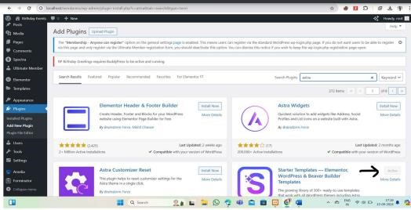

* **Choose the Birthday Celebration Theme:**
* After activating the Starter Templates plugin, go to Appearance > Starter Templates.
* Select the template that best matches your event (for example, birthday party themes).
* You’ll see a list of templates. You can either browse or use the search bar to find the birthday celebration theme.
* Click Import Complete Site to install the theme and all the demo content.
* **Customize the Content:** 
  + Go to Appearance > Customize. Here, you can modify the site's colors, fonts, layout, and more.
  + Change the text and images to reflect the details of the birthday event. You can customize the homepage, about page, contact page, or any other pre-built pages.
  + You can use Elementor or the Word Press block editor (Gutenberg) to edit each page visually, making it easy to customize text, images, and sections without any coding.
* **Add Additional Plugins (Optional):** 
  + RSVP Forms: Install a plugin like WPForms or Contact Form 7 to add RSVP forms for guests to register.
  + Event Countdown: Use a plugin like Countdown Timer Ultimate to display a countdown for the event date.
  + Social Sharing: Install Social Snap or Add To Any to allow people to share the event on social media.
* **Preview and Launch the Site:** 
  + - Once you've customized your theme and content, preview the site to ensure everything looks perfect.
    - When you're happy with the design, publish the changes.
* **Staging Environment:** Create a staging environment that mirrors your production environment but is accessible only to you and your team. This allows you to test changes and ensure everything is working as expected before making them live.
* **Through Testing:** Conduct comprehensive testing on the staging environment to identify and fix:
* **Functionality:** Ensure all features work as intended.
* **Usability:** Test the user experience to make sure it's intuitive and easy to navigate.
* **Compatibility:** Check how the site looks and functions on different devices and browsers.
* **Performance:** Ensure the site loads quickly and doesn't have performance bottlenecks.

### ****Export and Upload:****

* **Export Files:** If you're using a local development environment, export all necessary files, including themes, plugins, and content.
* **Upload to Server:** Upload the exported files to your production server using a File Transfer Protocol (FTP) client or your hosting control panel.

### ****Update DNS Settings:****

* **Point Domain to Server:** Update your domain name's DNS settings to point to the IP address of your production server. This will make your website accessible through your domain name.

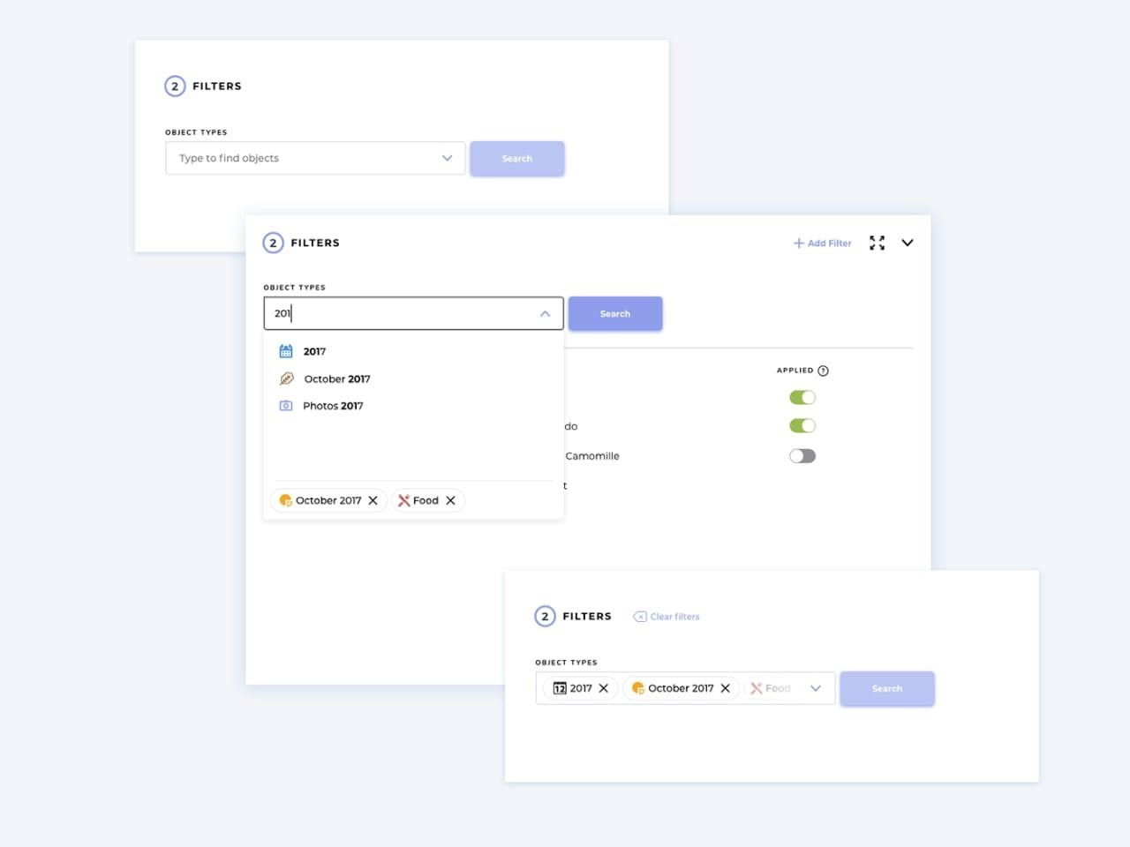

Before launching your website, it's essential to thoroughly preview it on various devices and browsers, test all functionalities, and check for performance issues. Once you're satisfied with the results, you can proceed with the launch by updating DNS settings, promoting your website, and monitoring its performance. Remember to create a staging environment, implement analytics, and back up your website regularly to ensure a smooth and successful launch.

Before making your website public, it's essential to thoroughly preview it to identify and rectify any errors or inconsistencies. Here are some key steps to consider:

* **Test Locally:** Use your local development environment to test all pages, features, and functionalities.
* **Check Cross-Browser Compatibility:** Ensure your website looks and functions correctly on various browsers (Chrome, Firefox, Safari, Edge).
* **Test on Different Devices:** Verify that your website displays and functions properly on different devices (desktop, mobile, tablet).
* **Check Form Submissions:** Ensure that forms submit correctly and provide appropriate feedback to users.
* **Test Interactive Elements:** Verify that buttons, links, and other interactive elements work as intended.
* **Check Load Times:** Ensure your website loads quickly and doesn't have any performance bottlenecks.
* **Test on Different Network Speeds:** Test your website on different network speeds to ensure it performs well in various conditions.
* **Launching Your Website:**

Once you're confident that your website is ready, you can proceed with the launch. Here's a general outline:

* **Choose a Launch Date:** Select a suitable launch date that aligns with your marketing strategy and target audience.
* **Update DNS Settings:** If you're using a new domain, update your domain registrar's DNS settings to point to your website's hosting server.
* **Check for Errors:** Double-check for any last-minute errors or issues before making your website public.
* **Promote Your Launch:** Create a marketing plan to promote your website launch and attract visitors. This may include social media campaigns, email marketing, and other promotional activities.
* **Monitor and Maintain:** After launch, monitor your website's performance, gather feedback from users, and make necessary updates and improvements.
* **Create a Staging Environment:** Use a staging environment to test changes and updates before deploying them to your live site.
* **Implement Analytics:** Set up analytics tools to track website traffic, user behavior, and performance metrics.
* **Back Up Your Website:** Regularly back up your website's files and database to protect against data loss.
* **Consider a Soft Launch:** A soft launch can help you identify and address any issues before a full-scale launch.

By following these steps and best practices, you can ensure a successful launch for your website and provide a positive user experience.

UI designers aim to create visually appealing, consistent, and user-friendly interfaces. They make sure that the look and feel of the product aligns with the brand and is intuitive for users.

**Key responsibilities of a UX designer:**

* Conducting user research to understand target audience needs and pain points.
* Designing user flows and wireframes to map out product functionality.
* Testing prototypes to gather feedback and improve usability.
* Ensuring accessibility for users with different abilities.
* Collaborating with developers and stakeholders to bring the design to life.

**UI vs. UX – Key Differences:**

* UI is about the appearance and aesthetics of the product.
* UX is about the functionality and overall experience of interacting with the product.
* UI focuses on visual design, while UX focuses on the user journey and ensuring it’s seamless.

**Why UI/UX Design Matters:**

* User Retention: A good UI/UX ensures users stay engaged and return to the product.
* Efficiency: A well-designed UX reduces user frustration, leading to better productivity.
* Branding: UI elements reflect the brand’s image, making it stand out.
* Accessibility: UX design helps create accessible products for all users, including those with disabilities.
* Both UI and UX work together to create a product that is both beautiful and functional, ensuring users have a positive and satisfying experience.

**SCREENSHOTS:**

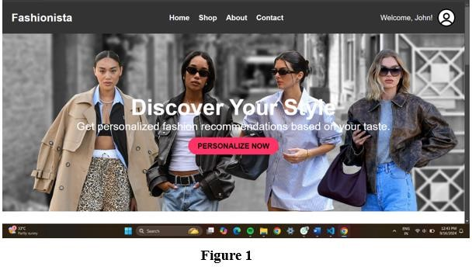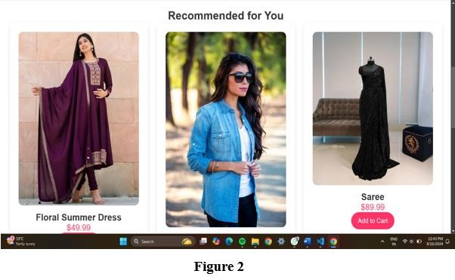

This product listing page aims to provide essential information about the products, facilitate easy addition to the cart, and encourage users to make purchase.

**E-Commerce Platform:**

* **Website Type**: Online Shopping Platform
* **Target Audience:** Allows users to add one or more products in clothing and traditional attire.

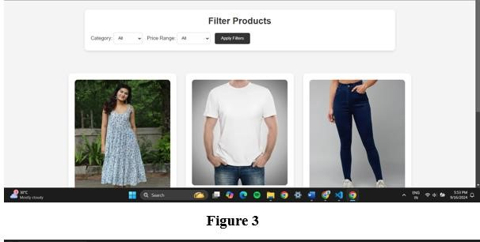

**Functions:** Allow users to add one or both products to their shopping cart.

**Purpose:** Encourages users to make a purchase.

This appears to be an e-commerce product listing page.

This page is likely part of an online shopping website, inviting users to purchase one or both of these products.

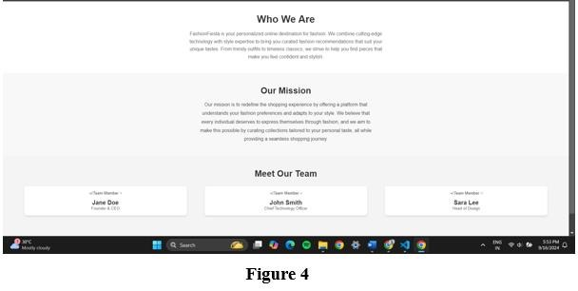

This figure is typically found on e-commerce websites and online marketplaces. It allows users to narrow down product search results based on various criteria, making it to find specific products.

**CONCLUSION**

The Personalized Fashion Retail Platform presents a dynamic solution for modern fashion e-commerce, addressing the growing demand for tailored shopping experiences. By integrating personalization features such as user preferences, style quizzes, and past purchases, the platform enhances user engagement, improves satisfaction, and drives customer retention. The seamless integration of frontend technologies like HTML5 and CSS3, coupled with backend solutions ensures a fast, responsive, and secure shopping environment.

This platform's core strength lies in its ability to offer a curated shopping journey for each user, utilizing data analytics and AI to suggest products that align with individual tastes. Furthermore, the use of modern tools such as responsive design, real-time updates, and efficient payment gateways makes the platform competitive and future-proof.

The project not only exemplifies the power of personalization in e-commerce but also highlights the importance of user-centric design and technological scalability. By continuously evolving to meet user needs and preferences, the Personalized Fashion Retail Platform has the potential to set new standards in the fashion e-commerce industry.

### BIBILOGRAPHY

### 

The following resources were referred to during the analysis and execution phase of the project:

1. L. Miller, "Designing E-Commerce Websites: UX and Best Practices," Smashing Magazine, 2021.
2. A. Nielsen, "The Role of Personalization in E-Commerce," Nielsen Norman Group, 2020.
3. E. White, "UX Research for E-Commerce: Understanding User Needs," Interaction Design Foundation, 2021.
4. Web links:
   * [https://www.smashingmagazine.com](https://www.smashingmagazine.com/)
   * [https://www.nngroup.com](https://www.nngroup.com/)
   * [https://www.interaction-design.org](https://www.interaction-design.org/)

**CERTIFICATE**